bcc: coco-product-interest@; fo-all@ |  |  |  | Subscribe at coco-product-interest@
 | COCO Flash  The Newsletter for Connectivity Optimization  July 2023 |  | COCO Wiki | Contact Us | Prior Flashes
COCO Overview
Continuous Outbound Connectivity Optimizer (COCO) is a network optimization model that defines the optimal connectivity and CPT design of the outbound transportation network by evaluating tradeoffs across multiple business objectives such as cost, speed, attainment, and volume availability to maximize long term free cash flow. COCO simplifies and automates the network design process by establishing a framework of mechanisms which enable continuous, incremental optimization of the outbound network. Network design offers an entitlement of $1.1B by improving fill rates +571bps ($902MM) and by improving <=1D GVS +1,224 bps ($191MM). COCO has taken a goal to deliver $82M in annualized cost savings to the outbound network in 2023.
Highlights / Lowlights
- [HL] Prime Day. In partnership with GTS, COCO launched 3,400 O-D connections (bypass routes) to increase middle mile capacity during Prime Week. These routes connected existing lanes (CPTs) to form new physical routes which preserved Promise when SC hubs capped out. The bypass routes won 1.4M packages, providing a net uplift of $2.5M. Find additional details on the win here.

- [HL] Möbius US. COCO provided SCOT-IPC and GTS with the final FC->ZIP2 mothership mappings for the Möbius US lab. Möbius US addresses the circular dependency between inventory placement systems and outbound network design. COCO created a forward-looking outbound network design, assuming infinite inventory, which yields opportunities for either thicker or additional FC->AMZL direct injections.

- [HL] Non-Blocking Deployments. COCO launched non-blocking deployments to improve operational excellence. With this feature, COCO can prototype new features without first deploying to a production environment, allowing for more rapid experimentation and validation.

- [HL] Dynamic Outbound Capacities. COCO launched Part 1 of its Enhanced Capacity Model feature, which enables dynamic sourcing of current node capacities (FC, SCs, Air GW, AMZL) from ATROPS and current linehaul capacities (fill rate targets) from VLS. This feature replaces static capacity inputs in COCO with live, production data.

Call to Action – Lane Deprecations
In Wk 29, COCO recommended to deprecate 186 suboptimal CPTs carrying an annualized CPLF uplift of $28MM. See lane-level details here.

 |  |  | Week 28 | Week 29
1 | Sub-Optimal CPTs | CPTs Evaluated* | 1,648 | 1,598
2 |  | Sub-Optimal CPTs | 168 | 186
3 |  | In-Region CPTs | 149 | 166
4 |  | Cross-Region CPTs | 19 | 20
5 |  | Cube / CPT | 1011 | 1030
6 | Network Impacts | Total Weekly Savings ($M) | 0.54 | 0.54
7 |  | Linehaul | 0.60 | 0.60
8 |  | Carrier Mix | 0.10 | 0.06
9 |  | Sortation | -0.03 | -0.02
10 |  | Speed CP | -0.13 | -0.11
11 |  | NASC VAA (Before) | - | 99.8%
12 |  | NASC VAA (After) | - | 98.0%
13 |  | Promise Impact (Days / Pkg) | 0.004 | 0.003
14 |  | AMZL Carrier Mix (+/-) | -0.04% | -0.03%
15 |  | USPS Carrier Mix (+/-) | 0.04% | 0.03%
16 |  | UPS Carrier Mix (+/-) | 0.00% | 0.00%
17 | Route  Impact† | Miles Before | 342 | 352
18 |  | Miles After | 351 | 348
19 |  | Touches Before | 1.21 | 1.13
20 |  | Touches After | 1.26 | 1.19
*Includes Core CPTs <= 1,000 cube & Air CPTs (ground only) <= 400 cube
† Includes only packages impacted by deprecations

2023 Goal Tracking
 |  | Goal |  | Level | Status |  | Description |  |  |  |  |  |  |  |  |  |  |  |  |  |  |  |  |  |  |  |  |  |  |  |  |  |  |  |  |  |  |  |  |  | Teams
 |  | Adoption [KP #625521] |  | Team | Yellow |  | Adopt COCO as the primary source for connectivity optimization in the core OB network in 2023. |  |  |  |  |  |  |  |  |  |  |  |  |  |  |  |  |  |  |  |  |  |  |  |  |  |  |  |  |  |  |  |  |  | COCO, GTS
 |  | Path to Green: COCO + GTS aligned on inputs for (1) speed-CPLF matrix, (2) O-D connectivity tenets, (3) minimum IRA threshold.
 |  | Savings [KP #632261] |  | QBR | Green |  | Deliver $82M in cost savings to the US transportation network through COCO optimizations in 2023. |  |  |  |  |  |  |  |  |  |  |  |  |  |  |  |  |  |  |  |  |  |  |  |  |  |  |  |  |  |  |  |  |  | COCO, GTS
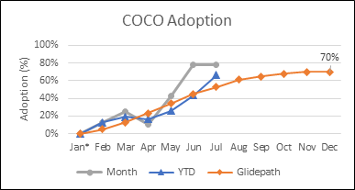 |  |  |  |  |  |  |  |  |  |  |  |  |  |  |  | 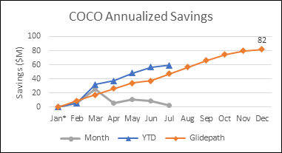
 |  |  | COCO Adoption (%) | Jan* |  | Feb |  |  | Mar |  | Apr | May |  |  |  |  | Jun |  |  |  | Jul |  |  |  | Aug |  |  |  | Sep |  |  |  |  |  | Oct |  |  |  | Nov |  |  | Dec
 | 1 |  | Month | - |  | 13% |  |  | 23% |  | 6% | 42% |  |  |  |  | 78% |  |  |  | 78%
 | 2 |  | YTD | - |  | 13% |  |  | 19% |  | 17% | 28% |  |  |  |  | 46% |  |  |  | 66%
 | 3 |  | Glidepath | - |  | 5% |  |  | 13% |  | 23% | 34% |  |  |  |  | 45% |  |  |  | 53% |  |  |  | 61% |  |  |  | 65% |  |  |  |  |  | 68% |  |  |  | 70% |  |  | 70%
 | 4 |  | Deprec. Proposed† | - |  | 379 |  |  | 384 |  | 277 | 130 |  |  |  |  | 37 |  |  |  | 0
 | 5 |  | Executed | - |  | 49 |  |  | 71 |  | 16 | 55 |  |  |  |  | 29 |  |  |  | 0
 | 6 |  | Launches Proposed‡ | - |  | - |  |  | 199 |  | 0 | 0 |  |  |  |  | 0 |  |  |  | 0 |  |  |  | 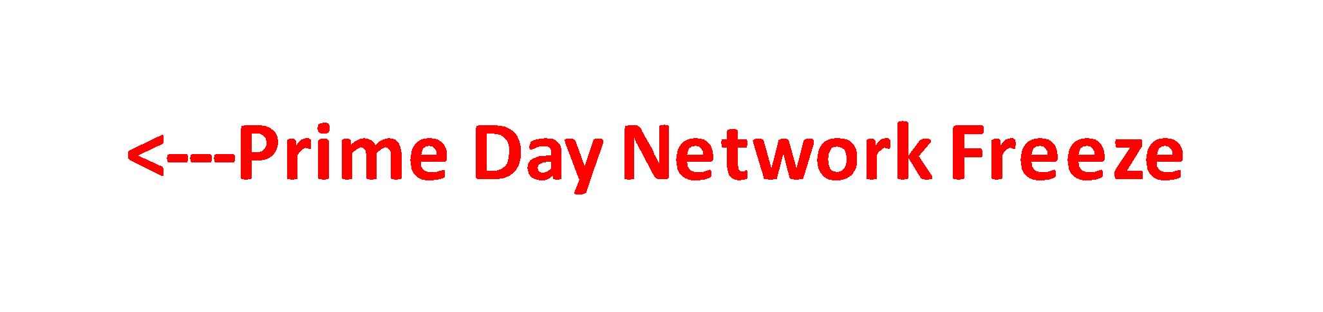
 | 7 |  | Executed | - |  | - |  |  | 66 |  | 0 | 0 |  |  |  |  | 0 |  |  |  | 0
 |  |  | Cost Savings ($M)
 | 8 |  | Month | - |  | 5.8 |  |  | 26.0 |  | 5.2 | 10.9 |  |  |  |  | 8.4 |  |  |  | 2.5
 | 9 |  | YTD | - |  | 5.8 |  |  | 31.9 |  | 37.1 | 48.3 |  |  |  |  | 56.7 |  |  |  | 59.2
 | 10 |  | Glidepath | - |  | 9.0 |  |  | 17.2 |  | 26.2 | 34.0 |  |  |  |  | 37.3 |  |  |  | 47.1 |  |  |  | 56.6 |  |  |  | 66.4 |  |  |  |  |  | 74.6 |  |  |  | 79.5 |  |  | 82.0
 | *COCO launched 1/24
 | †Includes Ground CPTs in Core + Air Networks (excl. 1T in-region connections)
 | ‡Includes FC->DS CPTs

Product Roadmap
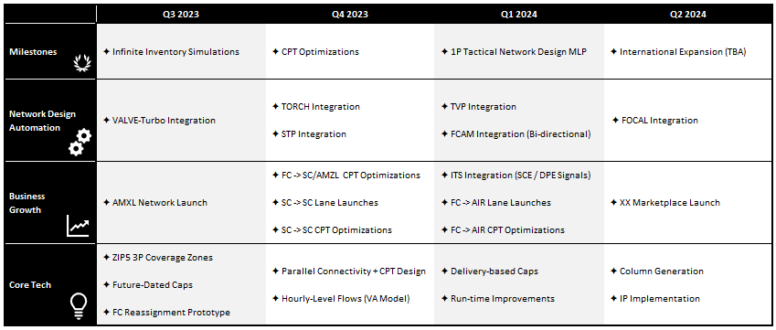
Get Started with COCO!
- Did you know you can run COCO using our WebUI and view results directly on COCO’s Quicksight Dashboard? Request access here!

- Check out our Wiki for how-to videos on running a COCO simulation and interpreting COCO’s output.

- Still not sure if COCO is the right tool for you? Here are just a few examples of COCO’s many use cases:
- Want to know which direct, 1-touch, or 2-touch connections in the outbound network are suboptimal?
- Want to launch new direct lanes but you’re unsure of the tradeoffs between cost, speed, attainment, and VA?
- Need to free up sort points at an FC but you’re not sure which CPTs to deprecate?

